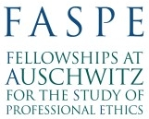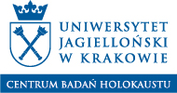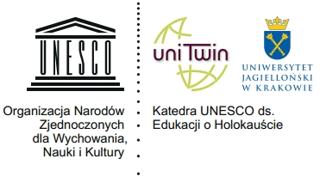

Dear Students,
we are inviting you to participate in program FASPE (Fellowships at Auschwitz for the Study of Professional Ethics) organized by The Museum of Jewish Heritage in New York in cooperation with the Center for the Holocaust Studies and UNESCO Chair for Holocaust Education at Jagiellonian University. The program is led in English. This year we are offered 2 places, one in journalist one in medical session for Jagiellonian University students. All cost are covered by FASPE beside the costs of visa to the USA.
Session for journalism students: May 21 - June 1, 2018
Session for medicine students: June 17-29, 2018
Applicants should send their CV (in English, 2 pages max.) and cover letter (in English, 1 page max.) to suszkiewicz.katarzyna@gmail.com till January 12th 2018. The letter of recommendation will be additional advantage but it is not a formal obligation.
The results will be published on the website www.holocaust.uj.edu.pl by the beginning of March 2018.
More information: www.holocaust.uj.edu.pl and http://www.mjhnyc.org/faspe/
Attention: the deadline in the original flyer are for American students.

